**JENKINS MASTER AND SLAVE**

**INTRODUCTION**

In today’s fast-paced software development landscape, continuous integration and delivery (CI/CD) have become indispensable practices for ensuring rapid and reliable software releases. At the heart of CI/CD automation lies Jenkins, an open-source automation server that enables developers to automate various stages of the software development lifecycle. In this blog, we’ll delve into the concept of Jenkins and explore the significance of its master-slave architecture in scaling CI/CD pipelines.

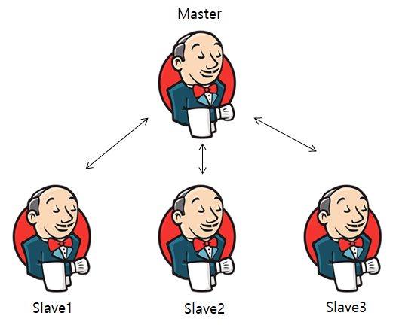

**Understanding Jenkins**

Jenkins is a widely-used automation server that facilitates the automation of building, testing, and deploying software applications. It provides a flexible and extensible platform for orchestrating CI/CD workflows, allowing teams to automate repetitive tasks and streamline the software delivery process. Jenkins supports integration with a myriad of tools and technologies, making it a versatile solution for modern software development teams.

**Master-Slave Architecture**

The master-slave architecture in Jenkins enables the distribution of workload across multiple nodes, thereby improving efficiency and scalability. In this setup, the Jenkins master node serves as the central controller responsible for managing job execution and distributing tasks to one or more slave nodes. Each slave node operates independently and executes build jobs assigned to it by the master. This distributed approach allows for parallel execution of tasks, reducing build times and enhancing resource utilization.

**Benefits and Use Cases**

**The master-slave architecture offers several benefits, including:**

* **Scalability**: Easily scale Jenkins infrastructure by adding or removing slave nodes based on workload demands.
* **Fault Tolerance**: Distributed architecture enhances fault tolerance and resilience against node failures.
* **Resource Optimization**: Efficiently utilize computing resources by distributing workload across multiple nodes.
* **Parallel Execution**: Execute multiple build jobs concurrently, accelerating the software delivery pipeline.

**Use cases for Jenkins master-slave architecture include:**

* **Large-Scale Builds**: Handle large and complex builds more effectively by distributing workload across multiple nodes.
* **Geographic Distribution**: Deploy slave nodes in different geographical regions to minimize latency and improve performance.
* **Specialized Environments**: Utilize dedicated slave nodes for specific tasks such as integration testing, deployment, or performance testing.

**Practical Guide: Setting Up Jenkins Master-Slave Architecture on AWS EC2**

**Prepare AWS Environment:**

Launch EC2 instances for Jenkins master and slave nodes, ensuring proper network configuration and security group settings.

**Jenkins Master Node:**

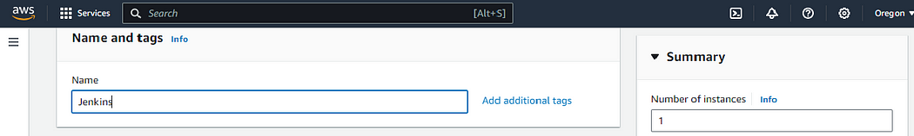

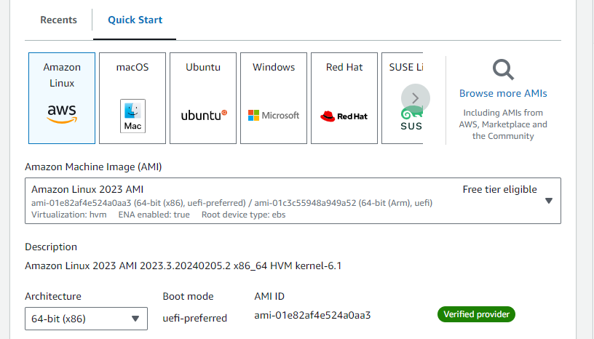

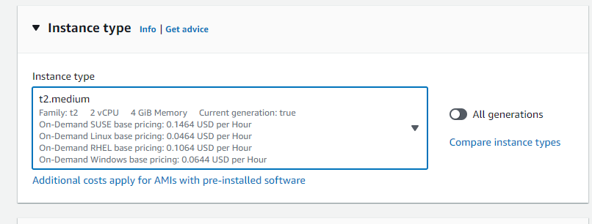

Create the new key pair for these instances also:

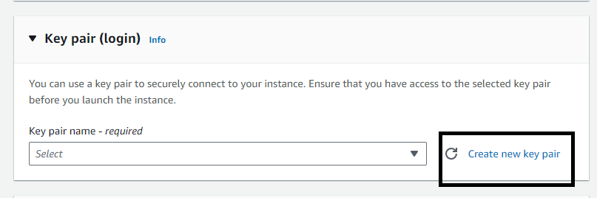

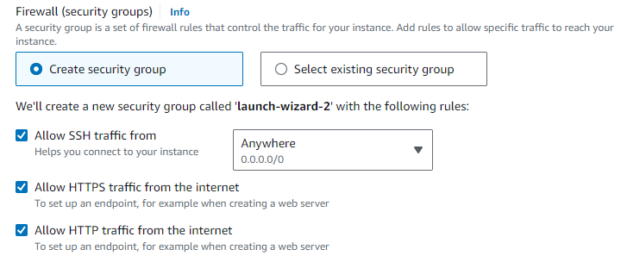

After successfully launching instance, install the Jenkins in master node and also install java.

**Jenkins slave nodes**

With the same instance configurations, we will launch the 1 Jenkins slave node and configure it from inside to launch the slave node

Basic Pre-requisite in slave node for its successful configuration:

sudo dnf install java-17-amazon-corretto -y

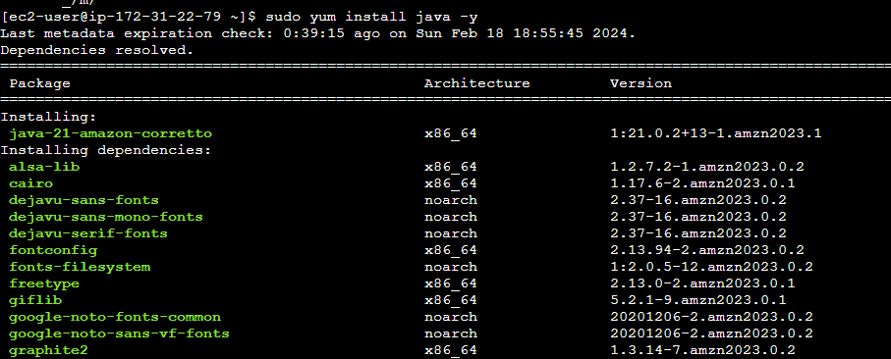

Now our plan is to set up one slave node for **Docker**builds.

**So first set up node as docker slave, run below command in that slave node:**

* + sudo yum install docker -y #linux 2023
  + sudo usermod -aG docker ec2-user
  + newgrp docker
  + sudo service docker start
  + sudo chmod 777 /var/run/docker.sock

**Access the Jenkins Master Node from WebUI**

Access the Jenkins master node on the browser using its public IP at port number 8080.

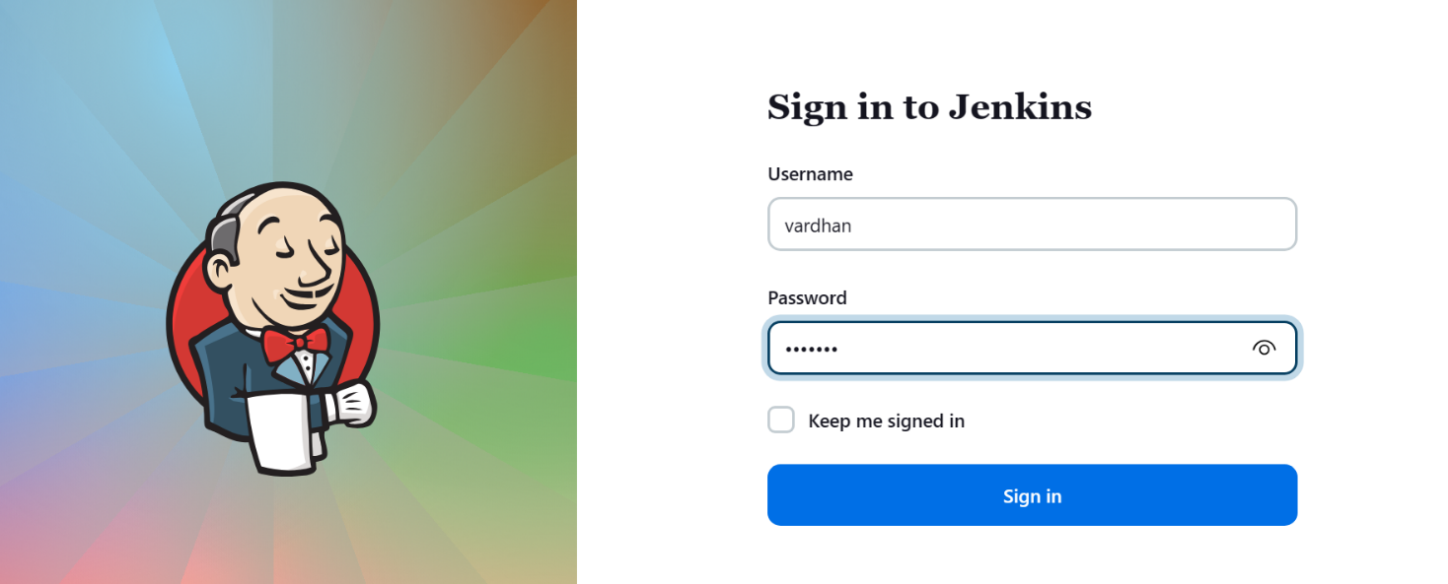

Go to the “Manage Jenkins” option from your dashboard :

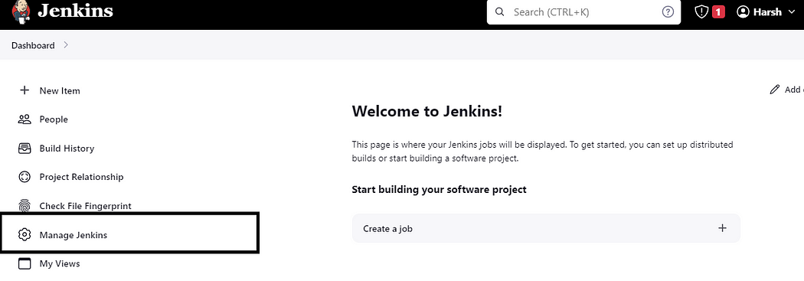

--Go to plugins install ssh agent.

**Setting Credentials :**

On the “Manage Jenkins” section, click on the “Credentials” in security section :

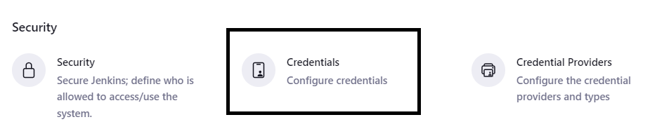

Click on “system” :

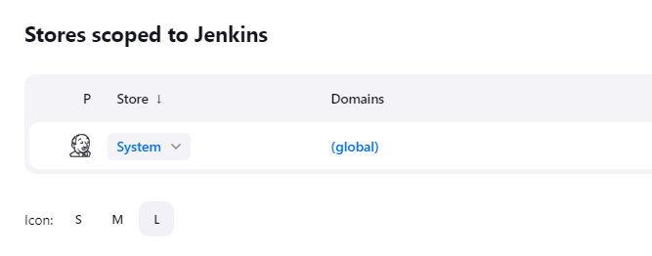

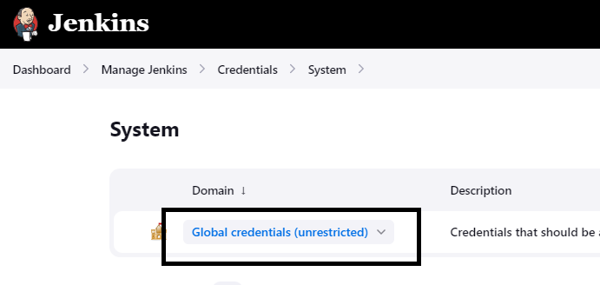

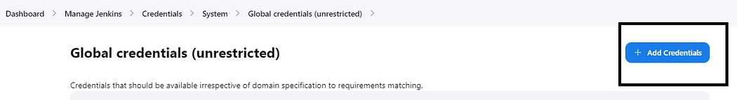

Choose “SSH Username with private key” on this option:

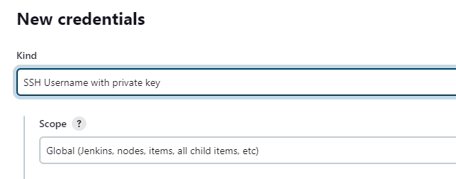

Then give the username you want to access, here we will give “ec2-user” and then copy the same key that we have created while launching the slave node.

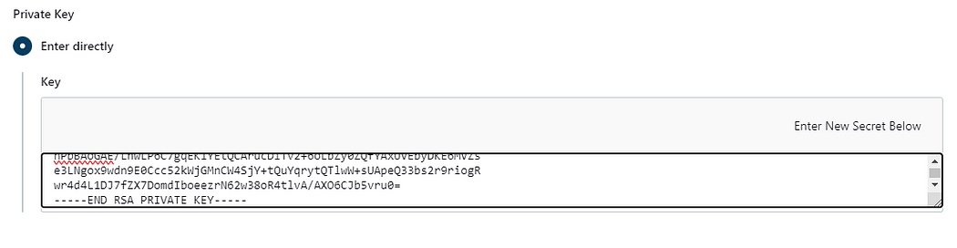

And create this credentials, so that we can use it while adding the slave node on the Jenkins.

**Go to the “Manage Jenkins” option from your dashboard :**



* + Go and search java path in master node and copy the java path

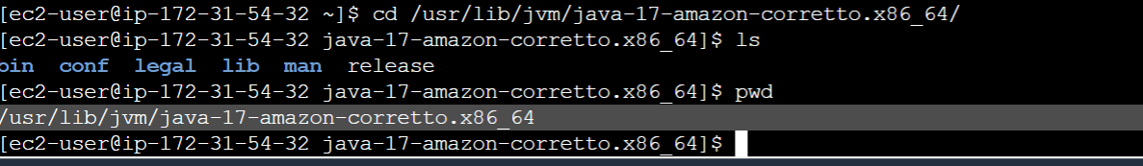

* + Manage Jenkins—tools- add jdk {java path}
  + Paste java path here and save

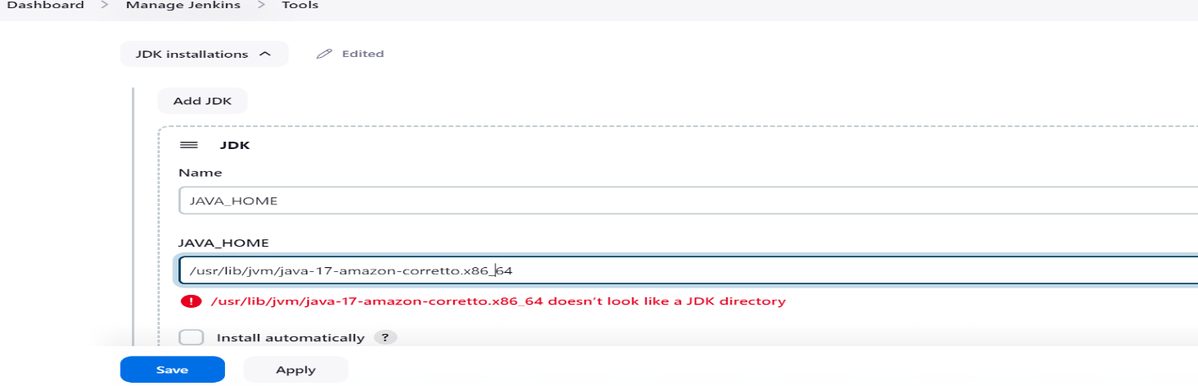

Click on “Nodes” option on your screen :

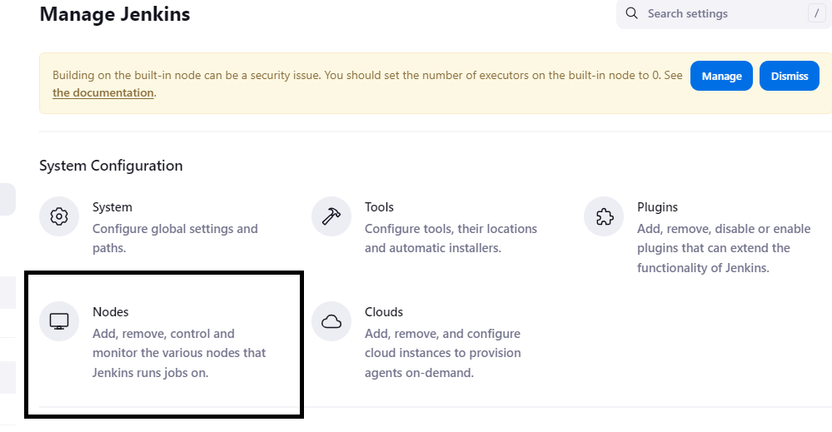

Then click on “+New Node” button.

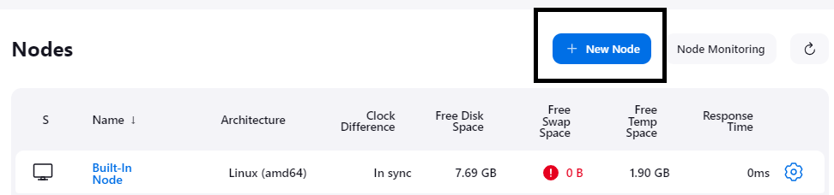

Then write the name you want to give to this slave node:

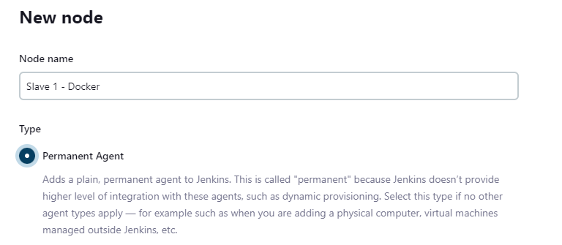

Then we will add further details for that node, i.e, number of executors and that workspace remote root directory is default other wise we can create and pass here:

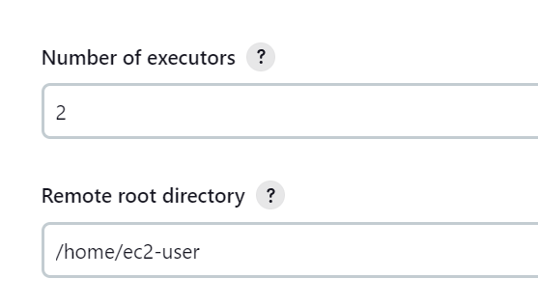

Then we will set label for that Slave node :

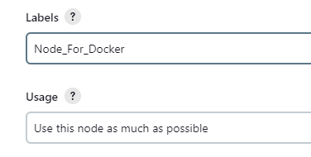

Then finally we will give the slave host details, i.e, its private IP and method of launching agent :

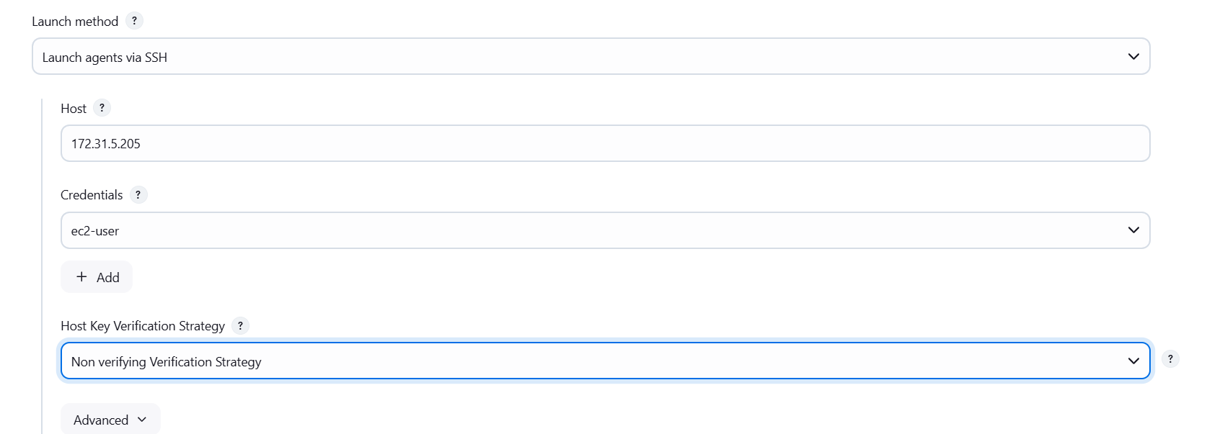

Keep the Host-key Verification Strategy to “Non verifying Strategy”.

For giving the “ec2-user” credentials that we can see here, we first have to create it separately on “Credentials” section of Jenkins :

* + Select disk space monitoring thresholds give 200mb in all fields

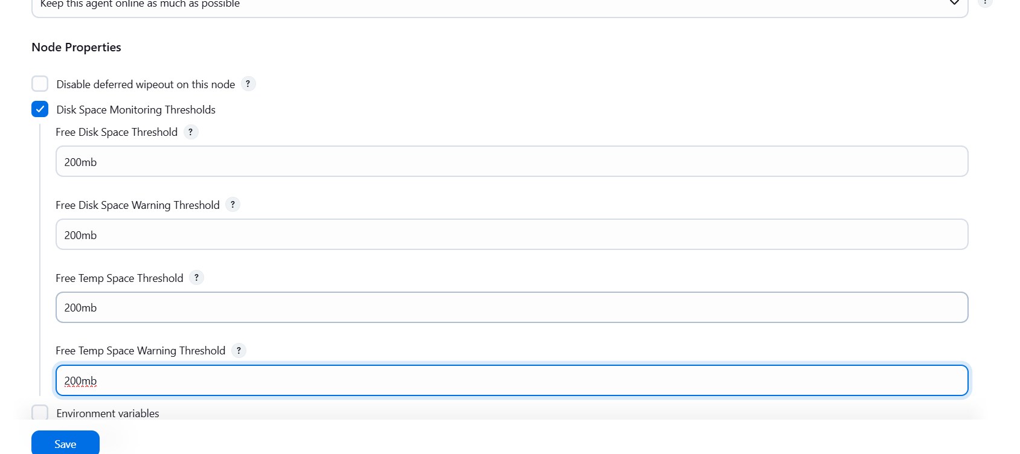

And finally our setup would be look like this :

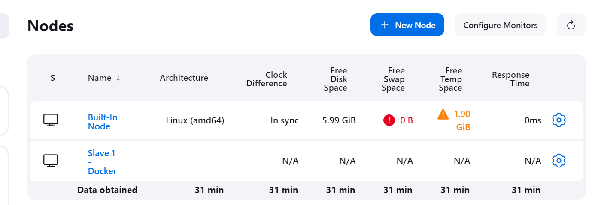

By implementing Jenkins master-slave architecture on AWS EC2, organizations can harness the power of distributed computing to accelerate their CI/CD pipelines and deliver high-quality software with greater efficiency and reliability.

equipped to leverage Jenkins’ distributed capabilities and propel your software delivery process to new heights of efficiency and agility.

* + Build the Jenkins pipe line

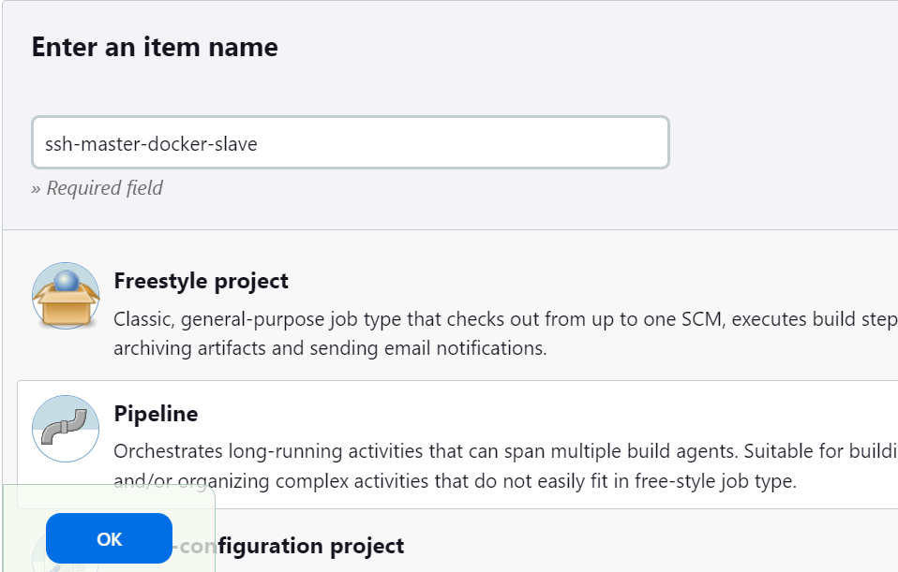

Write the pipe line script

pipeline {

agent {

label 'Node_For_Docker'

}

stages {

stage('pull') {

steps {

sh 'docker pull jenkins/jenkins'

}

}

stage('build-image') {

steps {

sh 'docker run -dt -p 8081:8080 jenkins/jenkins'

}

}

}

}

* + Build the code

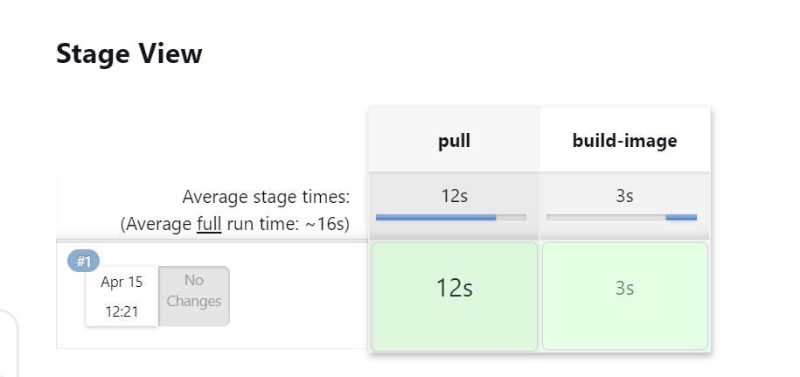

* + Go to slave node and check workspace, docker image, docker container created or not.

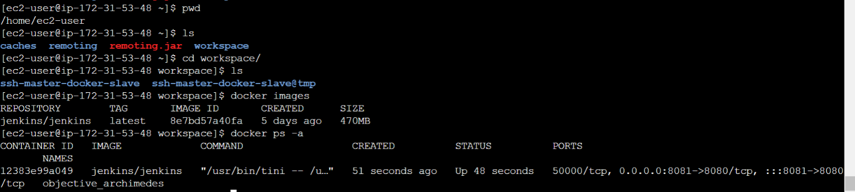

* + The master and slave is completed by ssh agent method.
* **Master and slave by other approach ( launch agent connecting it to the controller.**

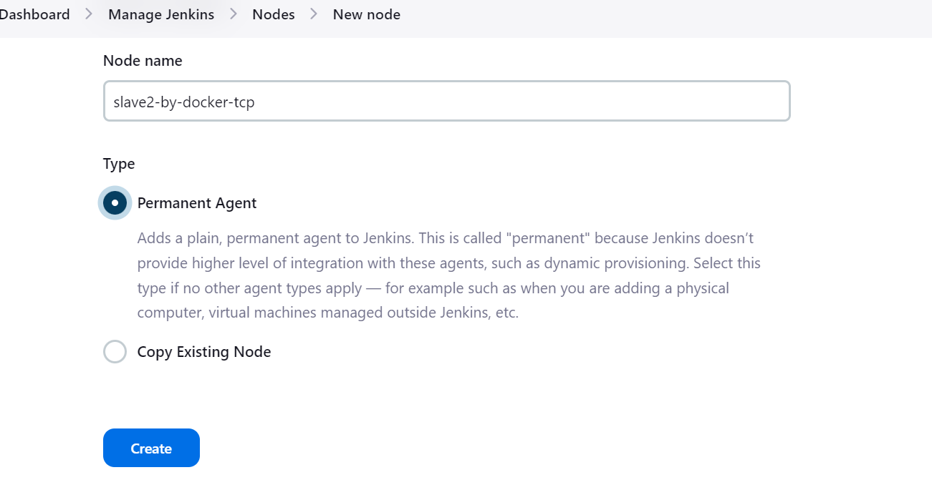

**Step 5:** Add a description of the node.

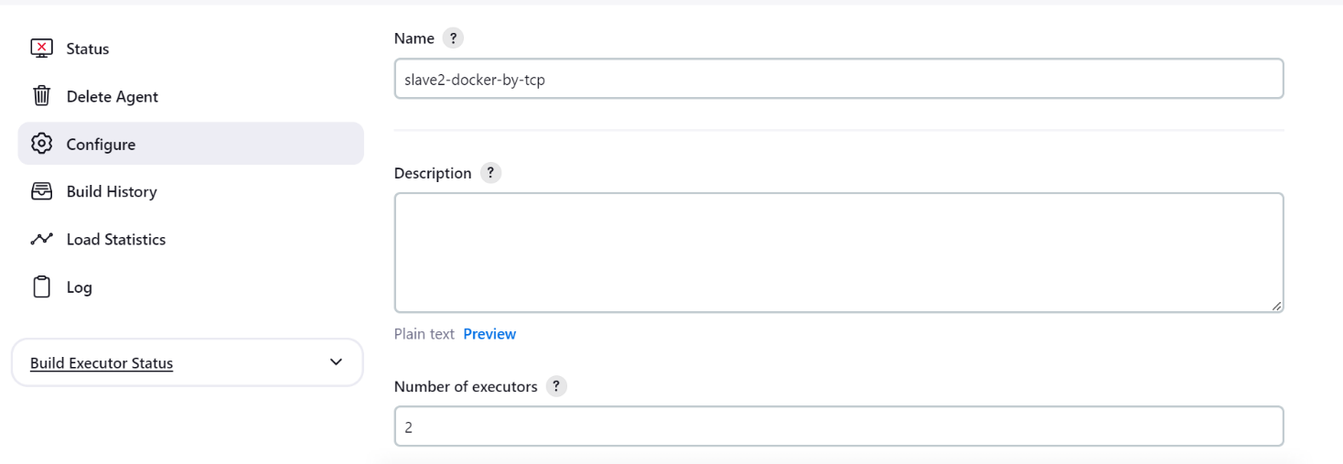

**Step 6:** Select the Number of executors to 2, generally equal to the number of vCPUs your machine has. It means how many parallel tasks this node can handle. If a task/ process requires one thread, then it consumes one core of your machine, which is how many vCPUs your machine has. So, we will be selecting this based on vCPUs.

Next, that workspace remote root directory is default otherwise we can create and pass here:.



**Step 7:** Add labels, for now, we have added docker-by-tcp-controller as the label; it is generally given as dev, stage, etc. Select Usage to Use this node as much as possible and the **Launch method to Launch the agent by connecting it to the controller.**

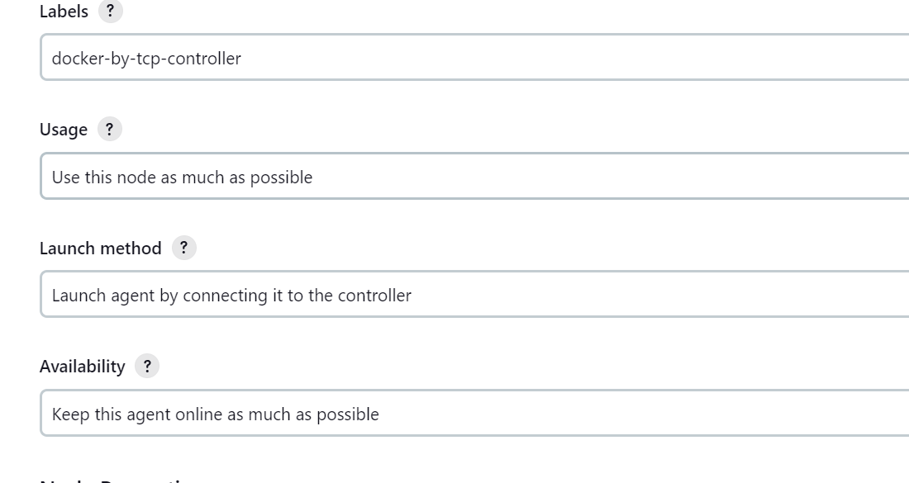

* + Select disk space monitoring thresholds give 200mb in all fields



**Step 10:**Click on “Save”.

--When you click “enter”, you will see a red cross in front of our Slave node. This means our agent is not yet connected. To connect our agent with the master node,

-- we need to follow some steps.

**Step-1 :** click on manage Jenkins 🡪 click on security 🡪 go to agents🡪 by default it is disabled 🡪 clik on fixed 🡪 give any port number (ex:5000) 🡪 then apply and save.

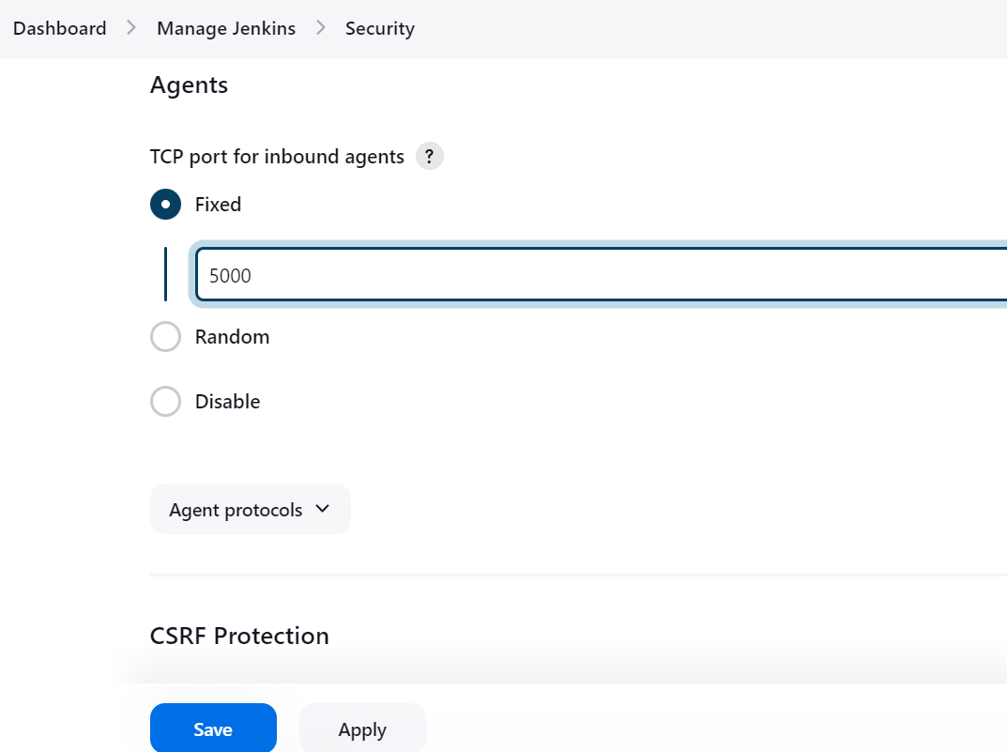

**Step-2 :** Click on “Slave”.

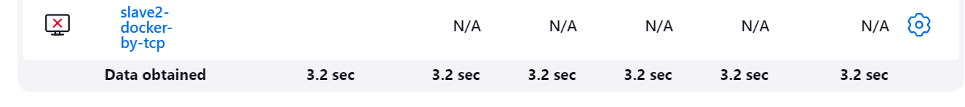

**Step-3 :** To connect with our master node, we need to install agent.jar on our master node. To install agent.jar, copy the command according to your environment and enter it onto your master node.

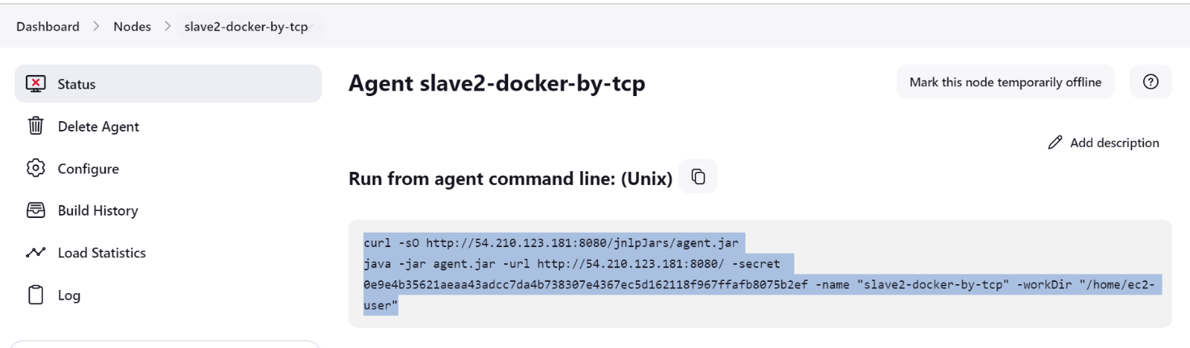

You will see something like this –

**INFO: “**Connected” indicates that your master node is successfully connected with your slave node.

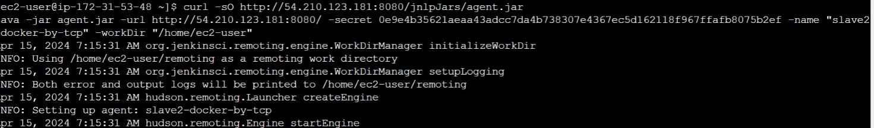 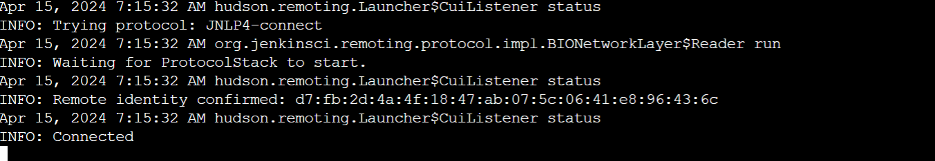

**Step-4 :** Now, to check whether it is connected or not, refresh the slave2 node.

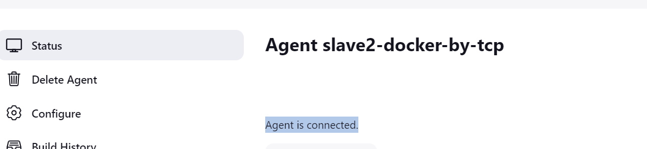

**Step-5 :** create a pipepline

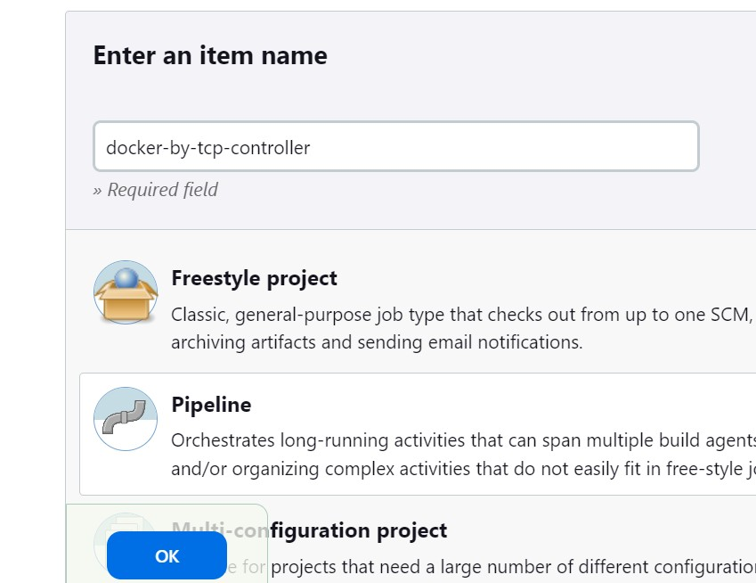

**Step-6 :** create a pipeline script for any sample application{httpd}

pipeline {

agent {

label 'docker-by-tcp-controller'

}

stages {

stage('pull') {

steps {

sh 'docker pull httpd'

}

}

stage('build-image') {

steps {

sh 'docker run -dt -p 81:80 httpd'

}

}

}

}

**Step-7 :** build the pipe line

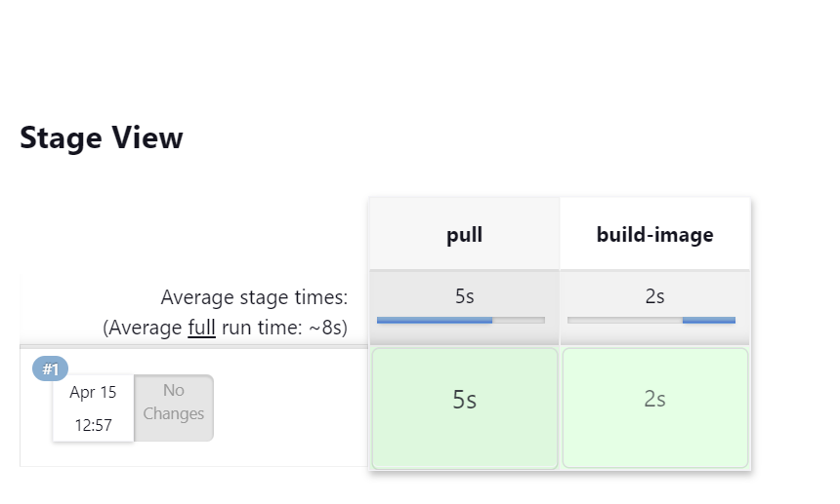

**Step-8 :** go to slave node and check docker image and container is created or not.

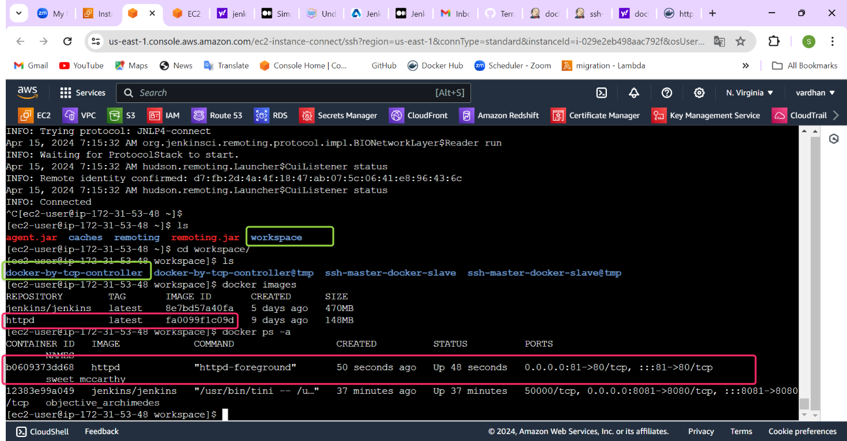

* + Master and slave other approach by ( launch agent connecting it to the controller. Is competed successfully